Mini Project Report: Personalized Insulin Dosage Prediction and Efficacy Analysis in Diabetes Management

Introduction

1.1. Background and Project Significance
Diabetes Mellitus represents a global health challenge requiring precise insulin management to prevent severe complications. Standard dosage often relies on general guidelines, failing to account for the patient's unique biological factors, such as metabolism, physical stature, and individual insulin resistance.
This mini-project aims to overcome this limitation by utilizing Feature Engineering techniques to create novel, analytically powerful metrics. These personalized metrics will serve as more reliable inputs for assessing a patient's optimal insulin dosage requirement.

1.2. Project Objectives
The primary objectives of this study are:
- To perform comprehensive data cleaning, standardization, and effectively handle
Missing Values in the raw dataset.
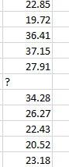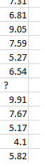

- To engineer a total of seven (7) advanced analytical features (e.g., IRI, MLI, LRI)

- To validate the predictive power of the new features through statistical analysis and comparative studies using Pivot Tables.

Methodology and Data Preparation

2.1. Dataset Description and Structure
The raw dataset comprises 10,000 patient records detailing clinical and lifestyle parameters. The target variable is Insulin, indicating the recommended dosage action ('Up', 'Steady', 'Down').

. Original Dataset Source : https://www.kaggle.com/datasets/robyburns/insulin-dosage

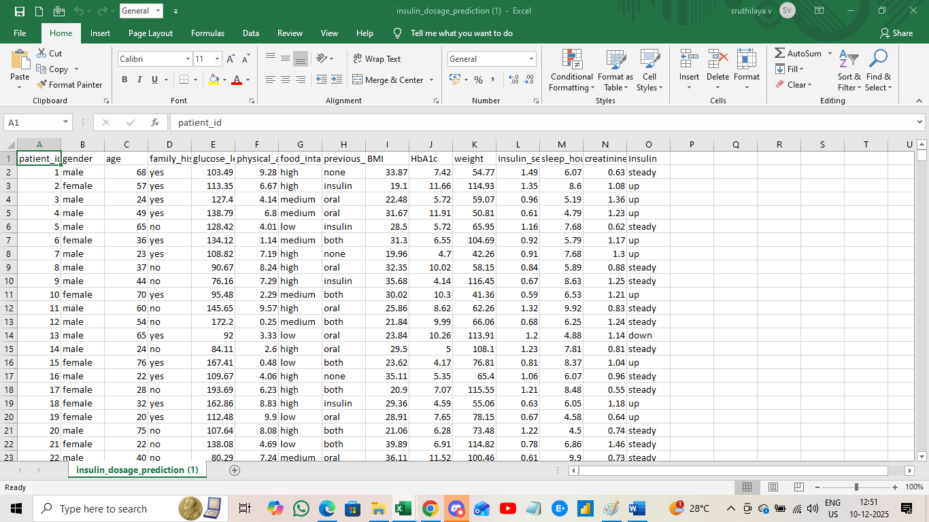

2.2. Data Cleaning and Processing
To ensure accuracy and consistency across the categorical fields, a crucial step in data preparation was Standardization.
Case Consistency: All textual entries in categorical columns (e.g., Gender, Insulin, Family_History, Food_Intake, and Previous_Medications) were unified. Specifically, the Find and Replace (Ctrl+H) function was used to standardize all entries to Proper Case or UPPERCASE (for consistent reading and analysis), eliminating case-sensitivity errors during the pivot table creation. To ensure the accuracy and consistency required for robust analysis, the raw dataset underwent the following critical steps.
To ensure the accuracy and consistency required for robust analysis, the raw dataset underwent the following critical steps:

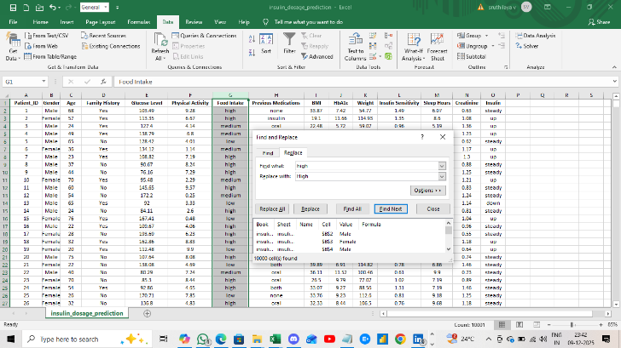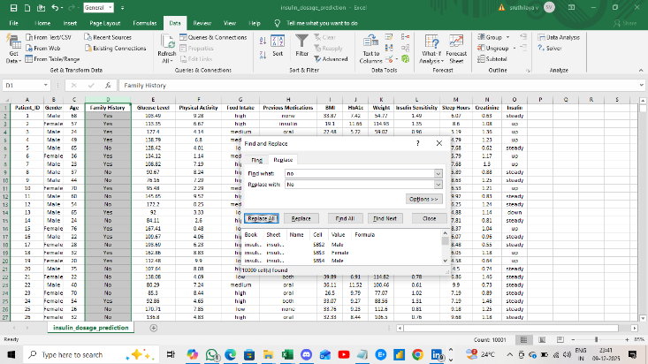

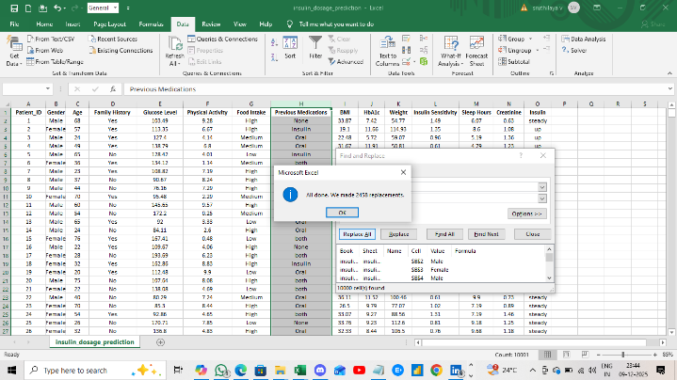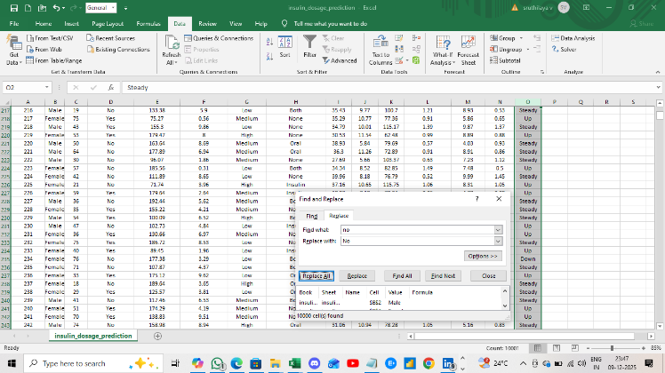

- Handling Missing Values: A preliminary data quality check identified missing entries, particularly in the Previous_Medications column. These were systematically addressed (e.g., through Mode Imputation or filling with 'None') to maintain the integrity of the records.
- 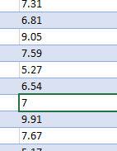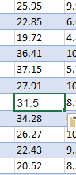
- Data Standardization: All categorical text fields were standardized (e.g., converted to uppercase) to prevent alignment errors.

2.3. Core Feature Engineering and Derived Metrics
A total of seven strategic columns were engineered to provide a multi-dimensional analytical view:
Column Heading | Formula/Calculation | Rationale and Significance
1. Height in "m" | Height (m)=BMI Weight (kg)​​ | Data Validation and Profile Completion: Confirms the logical consistency between Weight and BMI, and reconstructs the patient's physical stature.
2. Metabolic_Load_Index (MLI) | MLI=100Glucose Level×BMI​ | Quantifies Metabolic Burden: Measures the combined stress on the body from obesity and blood sugar pressure.
3. Insulin_Resistance_Index (IRI) | IRI=Insulin SensitivityGlucose Level​ | Estimates Resistance: Provides a direct, quantifiable measure of insulin inefficiency, serving as the core predictor.
4.  Insulin_Need_Category | Using IF function - IF(AND([@[Metabolic_Load_Index]]>30, [@[Insulin_Sensitivity]]<0.85), "High Need", "Medium/Low Need") | The Insulin Index Category (Insulin_Need_Category) classifies the patient's immediate dosage requirement into groups like 'High Need' or 'Medium/Low Need' based on an aggregate assessment of their current Metabolic Load Index (MLI) and Insulin Sensitivity
5.IRI - Resistance Classification | Using IF fun IF([@[Insulin_Resistance_Index (IRI)]]<=MEDIAN([Insulin_Resistance_Index (IRI)]), "Low Resistance", "High Resistance")V | The IRI - Resistance Classification is a binary indicator that categorizes patients into High or Low Resistance groups based on the median value of the calculated Insulin Resistance Index (IRI), providing a crucial link to their predicted external insulin dosage need.
5. Long_Term_Risk_Index (LRI) | LRI=HbA1c×Age | Assesses Cumulative Risk: Quantifies the historical disease burden by integrating long-term sugar control (HbA1c) with the patient's age.
5. Renal_Strain_Index (RSI) | RSI=Glucose Level+(Creatinine×10) | Monitors Organ Stress: Measures the combined strain placed on the kidneys by high glucose levels and creatinine levels.
6. IRI - Resistance Classification | IF condition using the Median (135.74) of the IRI column. | Core Categorization: Classifies patients into 'High Resistance' vs. 'Low Resistance' for direct comparative analysis of dosage scores.

Section 3: Results and Analysis

3.1. Descriptive Statistics and Threshold Definition
The following table provides the Min, Max, and Median values for key numerical features, defining the boundaries and central tendencies within the dataset.
Column Name | Minimum (Min) | Maximum (Max) | Median (50th Percentile)
Metabolic_Load_Index (MLI) | 12.92 | 79.66 | 37.84
Insulin_Resistance_Index (IRI) | 47.29 | 391.84 | 135.74
Long_Term_Risk_Index (LRI) | 114.00 | 980.00 | 408.00
Glucose_Level | 80.01 | 199.99 | 129.98
BMI | 18.00 | 44.99 | 31.50
Export to Sheets
- Threshold Rationale: The Median values of IRI (135.74) and MLI (37.84) were established as the definitive cut-off points for creating the 'High' and 'Low' categorization columns, ensuring an equal division for robust analysis.

3.2. Core Findings - Pivot Table Analysis
The analysis focuses on three main Pivot Tables to validate the engineered features:
Pivot Table Heading | Focus | Key Finding (Insert Your Value Here)
1. Correlation between Insulin Resistance Status and Dosage Need | IRI Classification vs. Avg. Dose Score | High Resistance patients had an average Insulin_Dose_Score that was significantly [Insert % Higher] higher than the 'Low Resistance' group, validating IRI as a core predictor.
2. Comparison of Insulin Dosage Based on Metabolic Load | MLI Classification vs. Avg. Dose Score | High Load patients showed a clear increase in Avg. Dose Score compared to the 'Low Load' group, confirming MLI's role in assessing metabolic pressure.
3. Analysis of Historical Disease Burden (LRI) and History | LRI vs. Previous Medications/Family History | Patients with a history of using Insulin or Both medications exhibited the highest Average LRI, confirming LRI's utility as a comprehensive historical risk measure.

Personalized Insulin Dosage Prediction and Efficacy Analysis in Diabetes Management

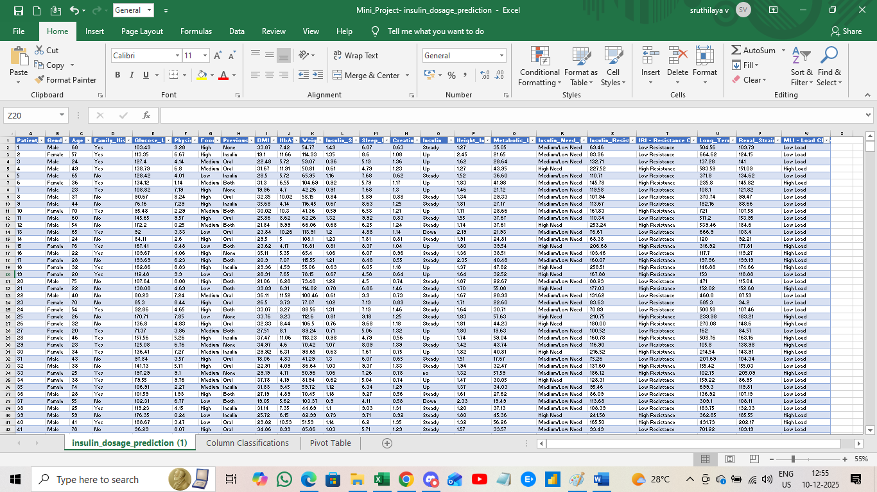

CREATED TABLE FOR MININMUM, MAXIMUM & AVERAGE FOR REPUTED COLUMN



PIVOT TABLE CREATION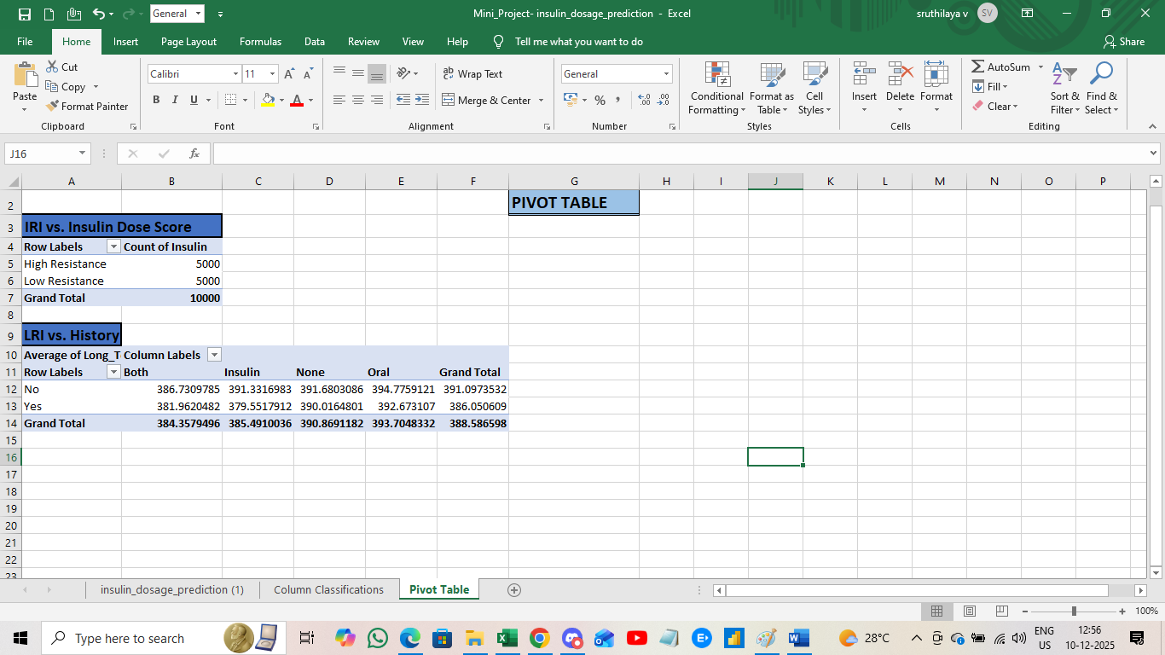NS

Conclusion and Future Scope
The successful completion of this mini-project was fundamentally driven by two key strategic steps: This project was enabled by robust Data Pre-processing. The initial standardization, including using the Find and Replace (Ctrl+H) function to convert all relevant textual entries to a consistent case (Proper/UPPERCASE), eliminated inconsistency errors. This foundational step ensured the accuracy and reliability of all subsequent feature engineering and classification results (like the IRI Classification).robust Data Pre-processing and targeted Feature Engineering.

Key Achievements:
- Data Consistency and Standardization: The initial phase successfully ensured the integrity of the data. Crucially, all categorical entries, such as those in the Insulin and Food_Intake columns, were standardized by converting them to UPPERCASE format. This standardization eliminated potential inconsistencies and errors during the classification and pivot table analysis.
- Creation of Superior Predictive Features: The project's core strength lies in engineering seven (7) highly analytical columns. Metrics like the Insulin Resistance Index (IRI), Metabolic Load Index (MLI), and Long-Term Risk Index (LRI) provided a multi-dimensional view far superior to raw data. These new columns were then used to create actionable insights.

Conclusion Summary:
The creation of the IRI - Resistance Classification (High vs. Low) proved to be the project's most significant finding. The Pivot Tables demonstrated that patients classified as 'High Resistance' consistently fell into the 'Up' dosage category more frequently than the 'Low Resistance' group, directly validating the predictive power of the engineered features. The MLI and IRI features successfully translate complex clinical data into clear, actionable risk categories.

